Ascribe to a Business Role with the New SAP Overview Pages

You are a business user looking for a coherent plan to increase your productivity. You have specific data but to different aspects of your role, so you look for ways to sort everything in one consumption.

Perhaps, a card layout that can classify everything can help:
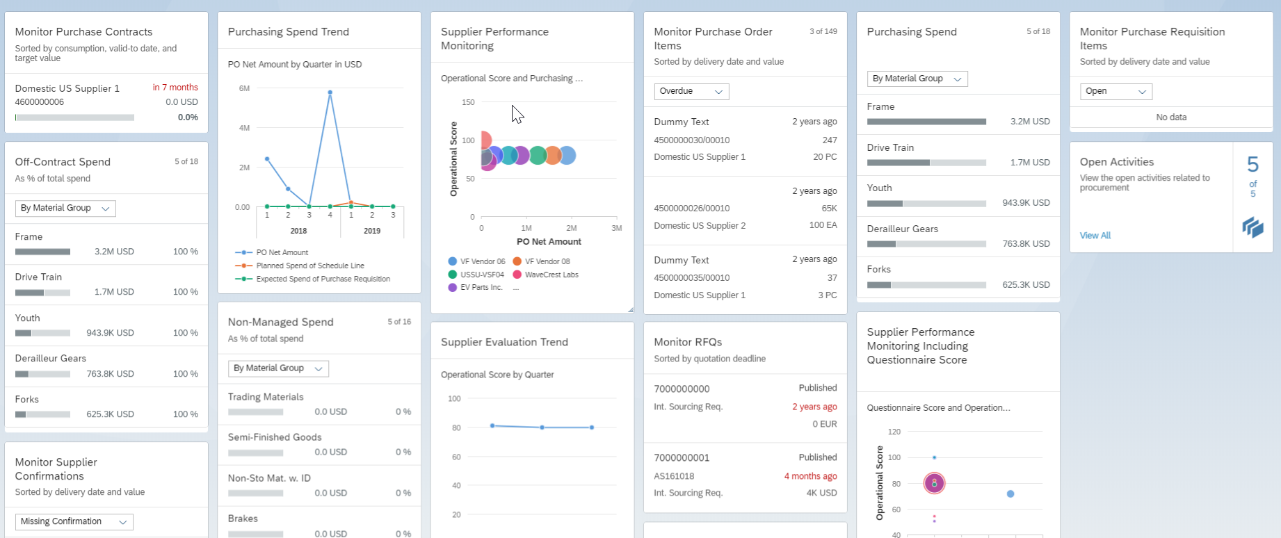

Quickly get an overview of what needs attention with the Overview Pages(OVPs), then trigger quick actions or drill down to the specifics! Ascribe to your business role and concentrate on your agenda for the day by arranging your cards in your OVPs according to your liking.

By using the OVPs, you will:

- Gain productivity and data quality
- Save training costs
- Decrease change requests and user errors
- Increase user satisfaction, customer loyalty, and solution adoption
- Strengthen your business relationships

We get it. You like to be organized—people think in chunks; and most likely, you do too. That’s why the OVPs bottleneck everything to you by specific domains.

Choose SAP S/HANA Trial to explore the Overview Pages with full flexibility and customizing options.

